**Image Resizing**

**Image down-sampling (resample at a lower rate):**

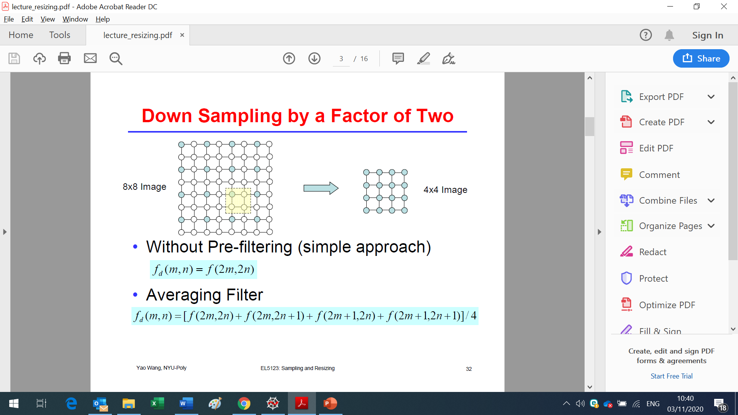

**Image up-sampling (resample at a higher rate)**

**Nearest Neighbor Interpolation**

**Bilinear Interpolation**

**Bicubic Interpolation**

**Nearest Neighbor Interpolation (pixel replication)**

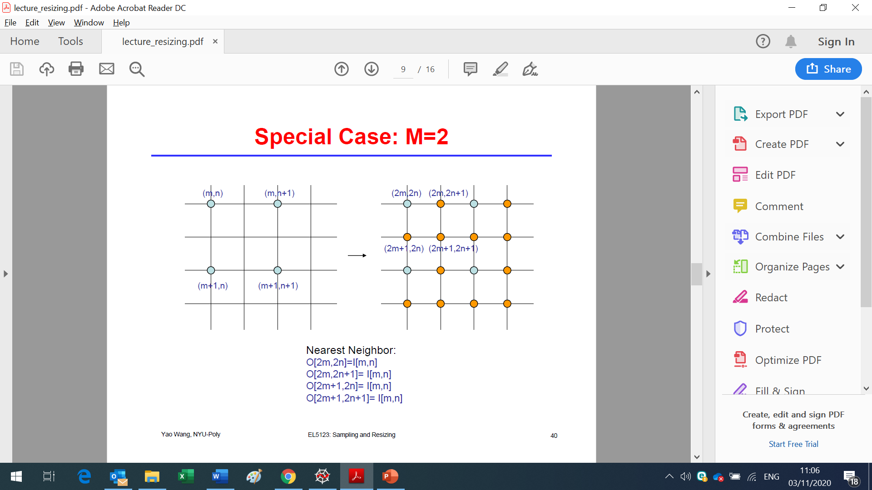

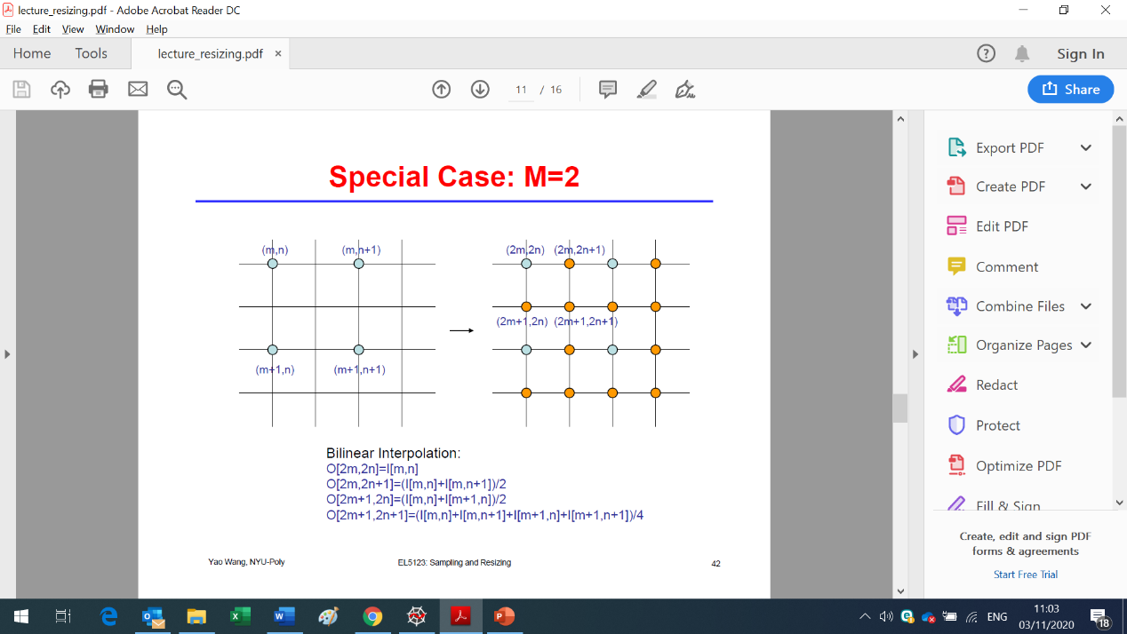**Bilinear Interpolation**

**Bicubic Interpolation**

